**Ansible Introduction**

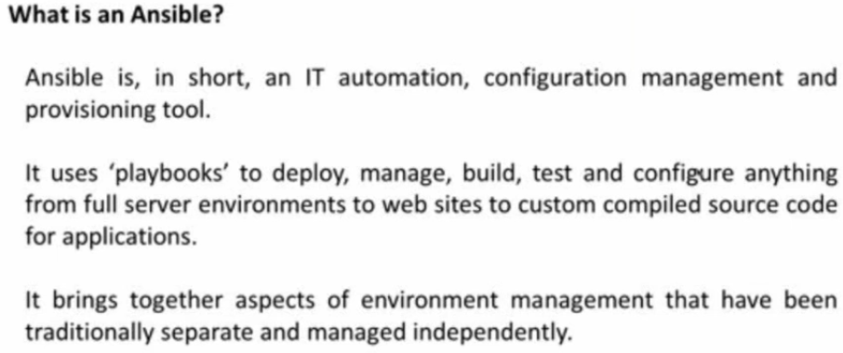

* Ansible is used to server configuration
* Configuration management tool is all about creating the environment for applications
* Shell script doesn’t guarantee the same state, but the configuration management will be same if anyone writes the script
* It gives the idempotence which means if we execute for 1000 times also, it gives same result
* Rather than telling how to do it, we tell what to do in configuration management tool. Then the tool will take care of it
* But in some cases, the tool might not know it. In that cases, we need to go for shell scripting
* For doing all these things we need a machine which can understand ansible

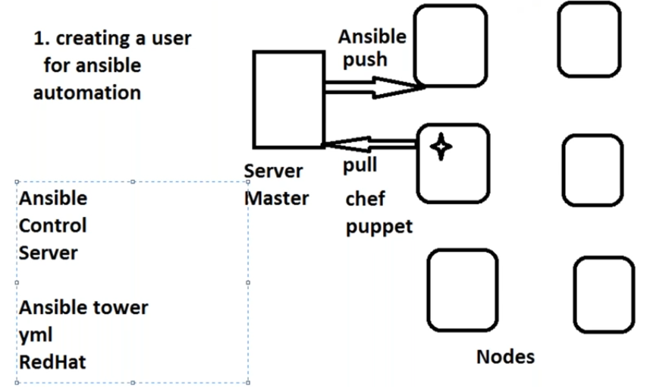

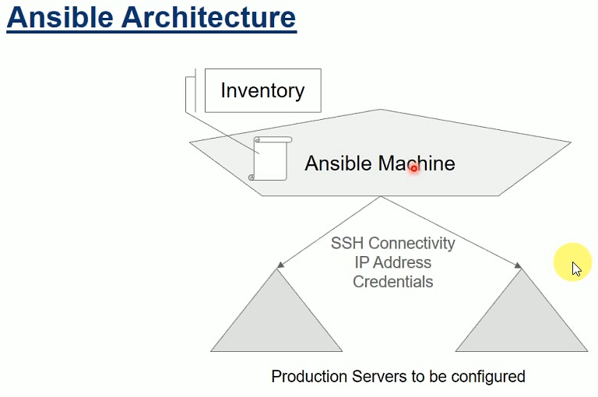

* In some configuration management, the servers called as nodes and in some we call as clients
* Server speaks to node, is called push model
* If nodes are asking the server, is called pull model
* Ansible is push model and chef, puppet is basically pull models
* To pull, nodes should know where the server is. By default, ansible knows where to push
* So, to work pull model, we need a software installed on the production server
* In case of push model, we need a create a user for ansible automation which ansible is aware of
* Target machine can be windows, but source machine cannot be
* Ansible control server, ansible tower
* Ansible tower is visual way of doing the things
* In ansible tower, we all need to write format called yml.xml
* Whatever we write in yml. It gets converted into python and gets executed in nodes
* When ever we are using yml, our OS should have python
* Ansible uses python
* If we want to develop in ansible. Then we need to learn python
* Ansible is maintained by redhat
* Apache webserver should be present
* **Install apache**
* After running this, it will check apache is installed or not and running or not. If it is installed and running, then it won’t do anything
* Rather than just installing it, it checks the status that we want. If the status is present as we want, then it won’t execute. Otherwise it will execute
* In ansible, we write something called as plays and we combine that plays to form something we called as playbook
* Playbook is nothing but an yml file
* The file where we tell what we want
* We will be writing that in a way ansible understand
* Tower is basically licensed from ansible.

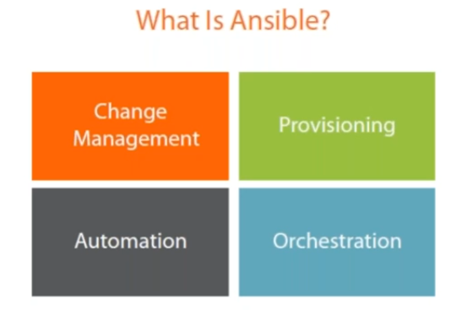

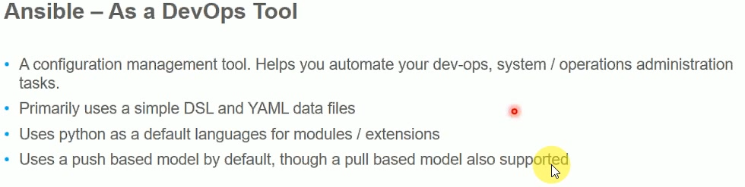

* If there is a change in application server. We write that in yaml file.so it will be applied on all the servers. Dev, test and prod servers. So that we won’t get any dependency issues

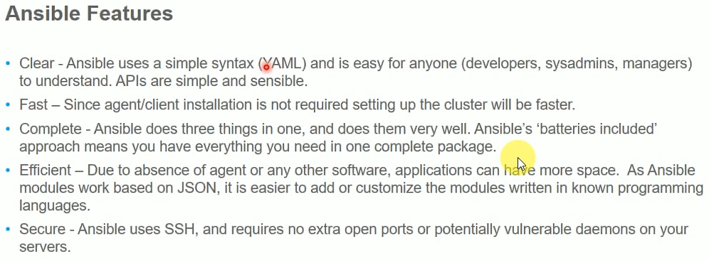

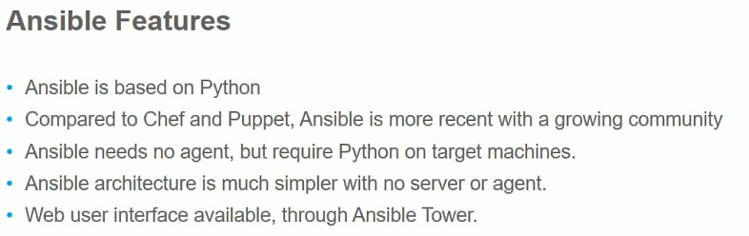

**Comparing with puppet:**

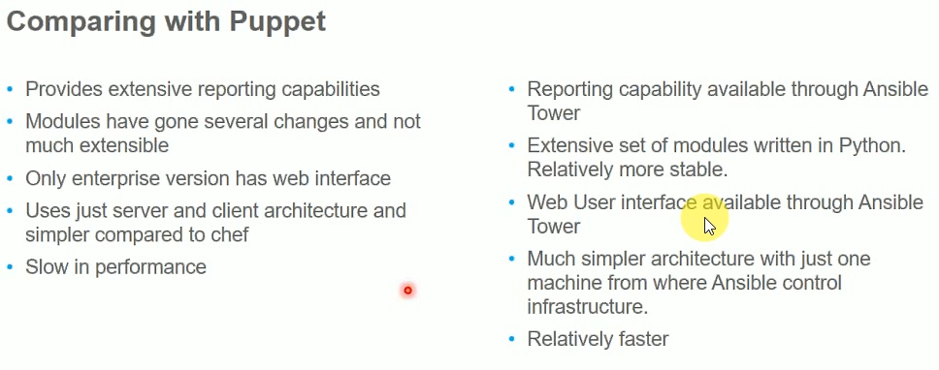

**Change management:**

* Change management is nothing but upgradation
* Example, if we want to upgrade from java 7 to 8. Then we want to write like java 7 should not be present and java 8 should be present
* We would enforce what we want

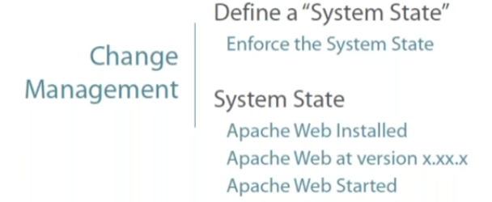

* Here we have set up to install apache and it should be running

**Provisioning:**

* Provisioning is basically creating infra

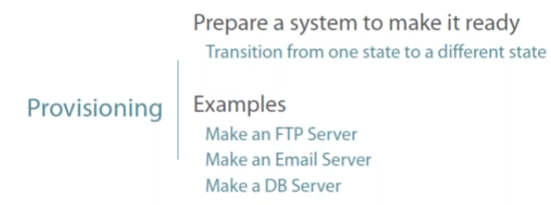

* This would contain small change management tasks

**Automation:**

* If we do it in one machine and want to apply all the machines. Is called automation
* Assume, daily we need to create a web server. So that the testers can test it tomorrow
* For this we write this and set it scheduler. For this we may use cron jobs or windows scheduler

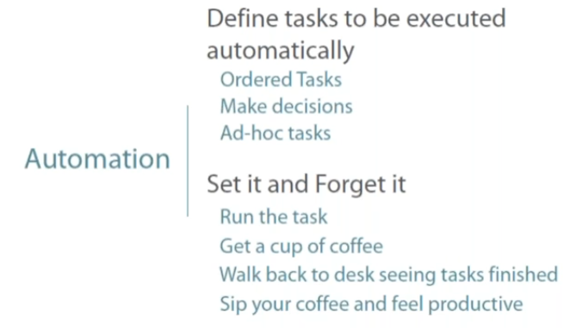

**Idempotence:**

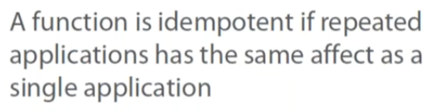

**Orchestration**

* Orchestration is like control server. Which can be used for ordering the playbook tasks. Which needs to be first and which needs to be next
* Here we can order the playbooks

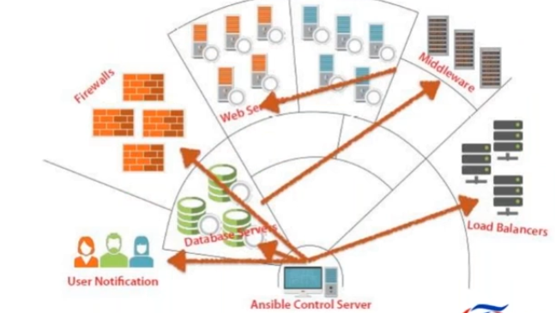

**What makes ansible different?**

* It needs no programming language

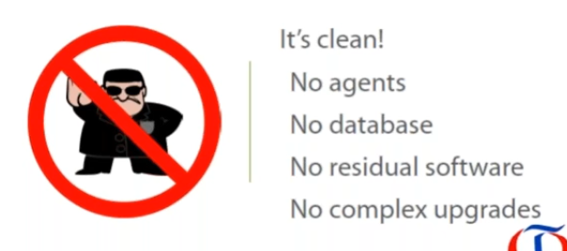

* In case of chef and puppet, the server needs to be heavy and there will be services
* In case of ansible, it is light weight, it is not service. It would work only when we execute the command
* If we go for ansible tower, it will be slightly heavy but not as chef or puppet
* Yml gets converted into python when we execute it
* So, without python, it won’t work

**How ansible works:**

* In master server, we will have ansible installed
* When we execute yml script. It will create an SSH connection to the node
* We need to have python in node server
* So, the script which we executed will be converted into python and gets executed
* This gets executed with a user which we have configured
* In case of windows, it is WinRM

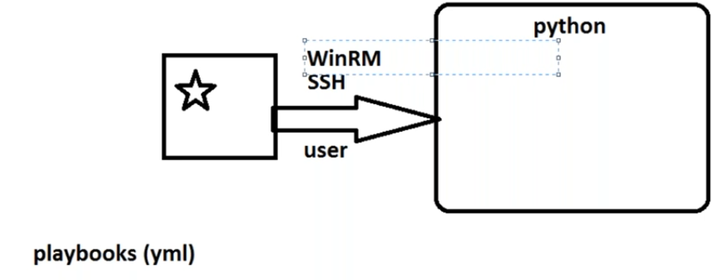

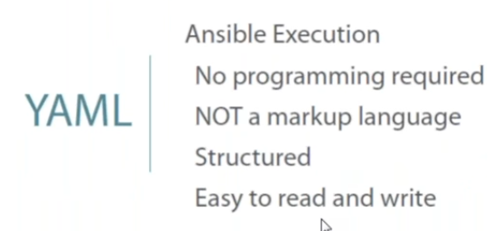

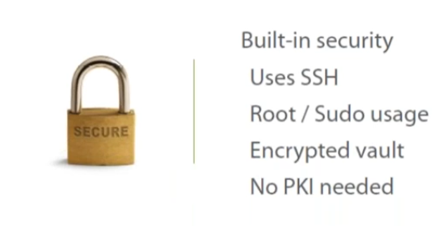

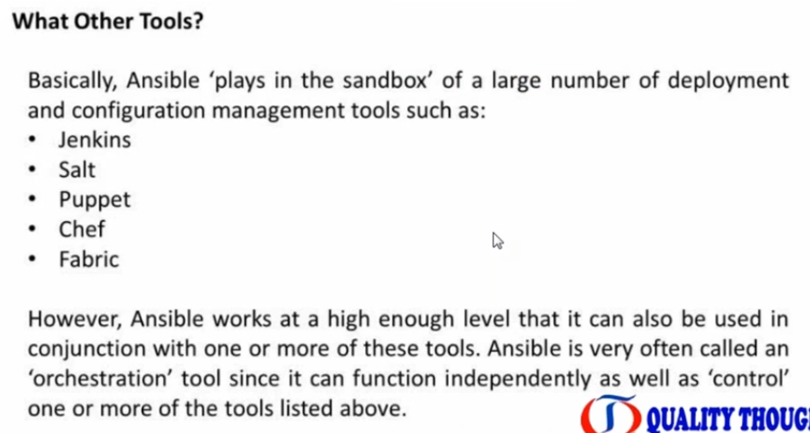

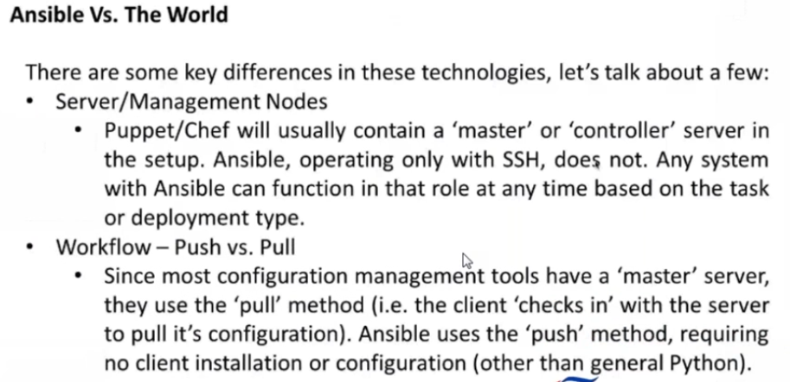

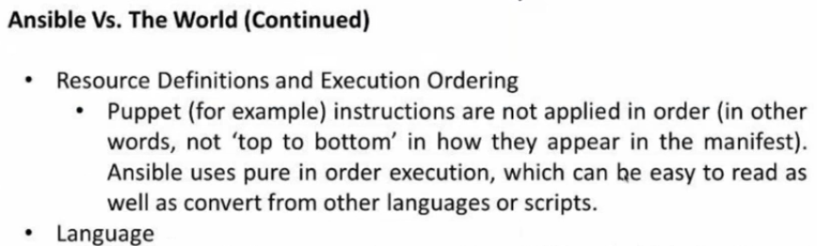

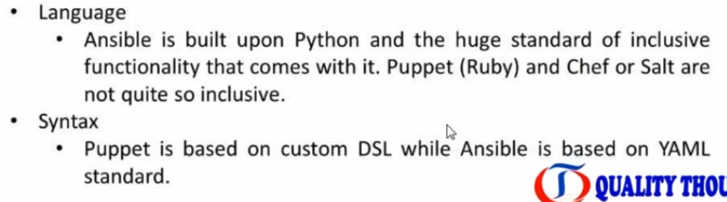

**Prerequisites:**

* Visual studio code is required. As it is useful to write yaml script
* Ansible is declarative method, not a procedural
* Node is actually production server
* People called it as ansible control server
* Ansible control server can not be on windows. But we can manage windows servers as nodes
* Even in chef, the server has to be Linux, but nodes can be different operating systems
* All servers need python installed in it

If we don’t have python in node machines, we can’t even ping them with ansible. Below is the error

